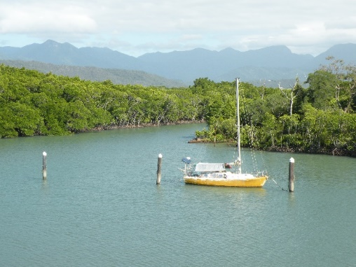Guest Survey Results

# **Southeast Asia and Oceania**

|  |  |
| --- | --- |
| **Total Tours** | 100 |

R2G coordinates volunteer experiences for non-profit organizations throughout Southeast Asia and Oceania. Most popular were the marine conservation projects in Australia followed by community aid projects in the Philippines and Indonesia. At the end of every volunteer experience, each guest completed the standard guest survey to evaluate the following five categories of service using four ratings: Excellent, Good, Fair, and Poor:

* Tour Activities
* Volunteer Activities
* Accommodation
* Food
* Experience Leader

As shown in the column chart below, a significant percentage of the guests rated the Food as Fair or Poor. R2G will work with Rod Ng, the Director of the Southeast Asia and Oceania Regional Headquarters to investigate the reasons for these less than satisfactory ratings and then submit a report to head office in January 2018.

The Southeast Asia and Oceania region can be particularly proud that 90% of our guests rated their overall experience as either Excellent or Good.